**Chapter 5 Exercises**

Flattening

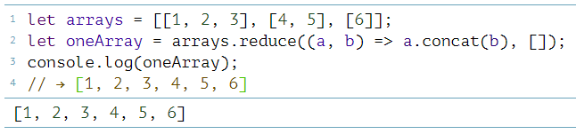

Your own loop

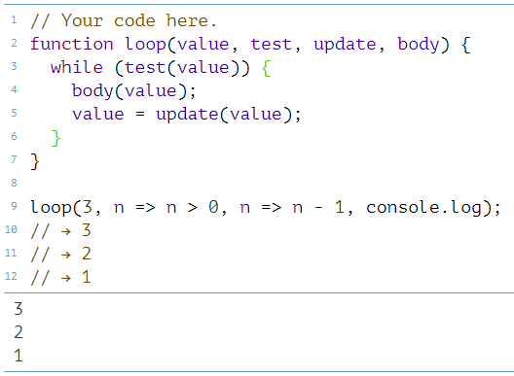

Everything

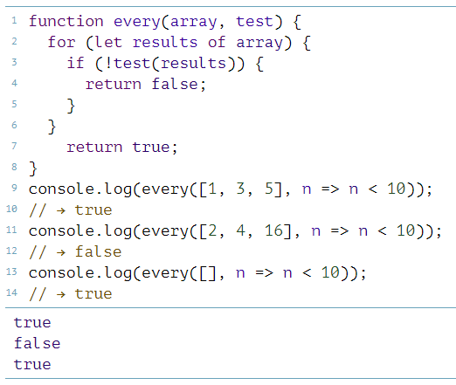

Dominant Writing Direction